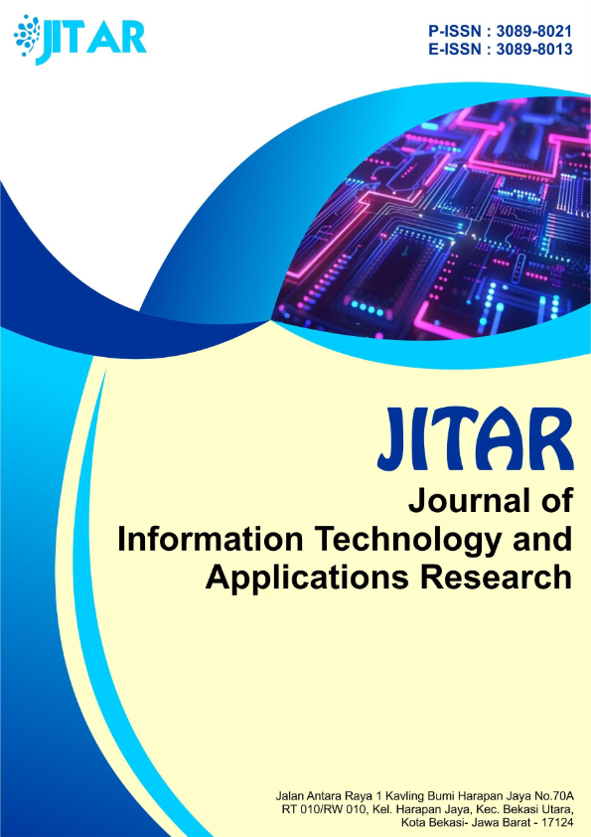
JURNAL Publikasi Ilmu Teknik dan Informatika, Vol.1, No.1, Mei 2021 hal 1-42

Volume.2 No. 1 May 2026

Journal of Information Technology and Applications Research (JITAR)
Volume 2 No 1 : May 2026

FOCUS AND SCOPE OF THE JOURNAL
DEVELOPMENT OF INFORMATION TECHNOLOGY

JITAR : Journal of Information Technology and Applications Research (p-ISSN : 3089-8021 (print), e-ISSN : 3089-8013 (online) ; https://jitar.org/index.php/jitar/index is a journal aims to serve as a platform for academics, practitioners, and researchers both nationally and internationally to share ideas, approaches, and strategic solutions that support the advancement of knowledge, challenges, and opportunities in areas such as Artificial Intelligence, Data Science, Cybersecurity, Big Data, IoT, Robotics, Automation Systems, Software Development, Networking, as well as relevant topics in Computer Science, Informatics, and Multidisciplinary Applied Technology.
Starting in 2025, JITAR only accepts manuscripts based on original research (top priority) and new scientific review articles (not priority). All submitted articles undergo a rigorous peer-review process, and the final decision regarding publication rests with the Editorial Board based on recommendations from qualified reviewers.
JITAR is published twice a year in May and November and is available in both print and online formats. Articles must be written in English. The decision to accept or not a scientific article in this journal is the right of the Editorial Board based on the recommendation of reviewer Partners.

JOURNAL INDEX INFORMATION
JITAR : Journal of Information Technology and Applications Research (p-ISSN : 3089-8021 (print), e-ISSN : 3089-8013 (online); https://jitar.org/index.php/jitar/index is a peer-reviewed journal that has been indexed in several reputable indexers, including: Google Scholar, Crossref, PKP Index and Copernicus







Journal of Information Technology and Applications Research (JITAR)
Volume 2 No 1 : May 2026

CHAIRMAN
Dr. Adam Huda Nugraha, S.Kom., MMSI

EDITORIAL TEAM

(Editorial Board):
Dr. Muhsin Nor Paizin, Zakat Academy (AZKA), Malaysia
Dr. Dheeraj Mandloi, Institute of Engineering and Technology, India
Engineer Md. Safaet Hossain, University of Information Technology and Sciences (UITS), Bangladesh
Andri Cahyo Purnomo, S.Pd., M.Pd. , Universitas Raharja, Tangerang, Indonesia
Ika susanti, S.Pd., M.Hum, Institut Teknologi dan Bisnis Semarang, Semarang, Indonesia
Melia Dwi Renovriska, S.Pd., M.Pd., Universitas Perwira Purbalingga, Jawa Tengah, Indonesia

Peer-Reviewers:
Mr. Moses Adeleke Adeoye, Al-Hikmah University Ilorin-Nigeria
Dr. Lok Raj Sharma, Makawanpur Multiple Campus, Hetauda, Nepal
Kim De Silvia, Universiti Kuala Lumpur, Malaysia
Syamsia,S.S.,M.Pd, STKIP Kie Raha Ternate, Maluku Utara, Indonesia
Arifah Nian Ekasari, M.Pd. Universitas Terbuka, Indonesia
Darul Islam,S.E.,M.M.CMA, Universitas Trunojoyo Madura, Indonesia

Publisher:
STT DUTA BANGSA

Address: Jalan Antara Raya 1 Kavling Bumi Harapan Jaya No.70A
RT010/RW010, Kel. Harapan Jaya, Kec. Bekasi Utara, Kota Bekasi- Jawa Barat(17124)
Tlp. (+62) 85183015224

email: journaljitar@gmail.com; website : www.jitar.org

Journal of Information Technology and Applications Research (JITAR)
Volume 2 No 1 : May 2026

PREFACE
JITAR : Journal of Information Technology and Applications Research (p-ISSN: 3089-8021 (print), e-ISSN: 3089-8013 (online); Volume 1 No. 1 Year 2025 (May 2025) is the first edition to be published in 2025. Articles published by the JITAR Journal have been published in Full text and Open Access in PDF format online at: https://jitar.org/index.php/jitar/index Starting in 2025, only articles originating from research results can be published in the JITAR journal after being reviewed by reviewer partners.
JITAR : Journal of Information Technology and Applications Research published the only paper that strictly followed the JITAR guidelines and templates for manuscript preparation. All submitted manuscripts will go through a double-blind peer-review process. The paper is read by editorial members (according to the field of specialization) and will be screened by the Managing Editor to meet the criteria required for JITAR publication. Manuscripts will be sent to two reviewers based on their historical experience in reviewing manuscripts or based on their area of ​​specialization. JITAR has reviewed the form to keep the same item reviewed by two reviewers. Then the editorial board makes a decision on the reviewer's comments or suggestions.
Reviewers give an assessment of originality, clarity of presentation, and contribution to the field/science. This journal publishes research articles, review articles/literature reviews, case reports and concept or policy articles, in all fields of information technology, including Artificial Intelligence, Data Science, Cybersecurity, Big Data, IoT, Robotics, Automation Systems, Software Development, and Networking. Articles to be published are original works and have never been published. Articles submitted will be reviewed by a team of reviewers who come from internal and external to the Indonesian Young Lecturer Foundation. JITAR is published periodically every 2 months, namely in May and November.
The Editorial Board will strive to continuously improve the quality of the journal so that it can become an important reference in the development of Information Technology and Applications Research. The highest appreciation and gratitude go to reviewer partners along with the members of the Editorial Board and all parties involved in the publication of this journal.
The Editorial Board also expects scientific articles from readers to be published in Volume 1 Number 1 May 2025 after going through a review process by the Editorial Board and/or reviewer Partners. Starting from Volume 1 Number 1 May 2025, the JITAR journal appears with a new environmental style and a new article format leading to a better one. Complete writing instructions for 2025 are displayed on this journal's portal.

Regards,
Chief of Board

Journal of Information Technology and Applications Research (JITAR)
Volume 2 No 1 : May 2026

TABLE OF CONTENTS
Focus, Scope and Indexation Information of Journals | i
Editor Team | ii
Preface | iii
Table of Contents | iv
TABLE OF CONTENTS

Example: (Can be obtained from the website.)

Data Mining Analysis of Influencer Credibility and Brand Trust in Social Media Marketing
P.Natarajan, Research Scholar, Bharath Institute of Higher Education and Research (BIHER), Chennai, Tamil Nadu, India
Arun Gaurav Ram, Associate Professor, Department of Visual Communication, Bharath Institute of Higher Education and Research (BIHER),, Chennai, Tamil Nadu, India
01-09

An Evaluation of User Satisfaction with the Ruangguru EdTech App Using a Lexicon-Based Sentiment Analysis Approach
Rahmat Febrian Putra, Gunadarma University, Indonesia
Wahyu Supriyatin, Gunadarma University, Indonesia
10-21

Application Planning Website Saribuah Fruit Sales with Stock Prediction Features and Digital Payment Integration
Rifki Ahmad Fahreizi, Gunadarma University, Indonesia
Ega Hegarini, Gunadarma University, Indonesia
Achmad Risa Harfit, Gunadarma University, Indonesia
22-33

Please ensure that all remaining information is updated according to the corresponding issue/publication on the official website.

All red-highlighted text should be removed before the manuscript is finalized.

